Objective 2: In-Depth Understanding of the Characteristics and Challenges of Digital Forensics in the Domain of IoTs – with a Special Focus on Persona and Smart-Home IoTs
IoT Forensics: Challenges, Methodologies and Future Directions
Introduction
- IoTs range from household items to industrial machinery and infrastructure systems
- Produce complex challenges, especially in digital forensics with data acquisition, analysis and preservation
  - Since data is dispersed between physical and virtual locations, it’s difficult to ensure evidence integrity and continuity
    - This is essential for maintaining reliability and admissibility of evidence
  - IoTs also have many different manufacturers, which means different technologies and communication standards being used
  - Security and encryption make it difficult for investigators to decrypt and analyze the data
- This creates an urgent need for development of standardized forensic methodologies and tools specific to IoT investigations
Challenges in IoT Forensics
- Each device may require different methods for data acquisition and analysis
  - Case-study: While investigating a smart thermostat, the data might be stored in a proprietary format using non-standardized communication protocols, which requires specialized tools like X1 Social Discovery (for cloud-based data retrieval) or FTK Imager (extracts data directly from the device)
  - Tech specifics: A smart camera might use proprietary video format and encrypt the data before transmission, which means investigators need to use Wireshark (for packet sniffing and capture the packets)
    - If encrypt is robust, they may need decryption keys or exploit vulnerabilities in the device’s firmware
- They produce massive amounts of data in real-time and can be distributed across multiple devices, networks, and cloud platforms (requires advanced processing techniques and scalable tools)
  - Case study: An industrial IoT system generates terabytes of time-series data daily; investigators may used Splunk for its ability to handle large volumes of log and sensor data, parse it, and visualize potential security breaches/anomalies
  - Tech specifics: Data comes in various formats (sensor = CSV/JSON, video = proprietary binary formats); investigators may need Autopsy (performs data carving) or EnCase (recovers fragmented/corrupted files). We also need the metadata like timestamps, device IDs, and sensor types to establish a timeline
- Often store data temporarily or in volatile memory so critical evidence can be lost if not captured quickly
  - Case-study: In a smart home security system, real-time sensor data may be overwritten as new data comes in; investigators might employ tcpdump (captures network traffic in real time) or FTK Imager (creates a memory dump from volatile memory)
  - Tech specifics: Investigators may use Wireshark (captures network traffic before data is overwritten/deleted) or Volatility (for volatile memory to capture it live which may contain encryption keys, credentials or session logs)
- Security measures protect data integrity and user privacy, but hinder investigations when attempting to access and analyze data
  - Case-study: A pacemaker with encrypted data transmits between the device and a mobile app; experts will need to extract decryption keys from the firmware with special tools like Cellebrite UFED (extracting data that interacts with IoT medical equipment)
  - Tech specifics: ElcomSoft iOS Forensic Toolkit (decrypts data from iOS devices associated with IoTs but need the necessary authentication)
- As the tech evolves, new areas present threats like edge computing and IoT-specific communication protocols
  - Edge computing: Processing data closer to the source rather than cloud servers (reduces latency and bandwidth efficiency but complicates data acquisition in terms of geographical locations)
    - Real Scenario: In manufacturing where IoT sensors collect data at the edge, an attack targeting the edge node can erase/manipulate evidence before it’s transmitted
    - Need tools to adapt to access and acquire data from various sources
  - Communication protocols like MQTT and CoAP are lightweight enough for IoTs to exchange data with
    - Message Queuing Telemetry Transport (MQTT): Used for real-time messaging in IoT systems, designed for low-bandwidth environments to transmit small amounts of data over unreliable networks
      - Vulnerable to MiTM and eavesdropping (lack of encryption)
      - Wireshark for capture but advanced techniques or access to encryption keys for decryption and analysis
      - Real Scenario: In a smart home, attackers can inject malicious messages in the communication stream between devices
    - Constrained Application Protocol (CoAP): Commonly used in resource-constrained environments, designed for low-power, low-bandwidth settings
      - Vulnerable to DoS and security weaknesses like incorrect implementations of security protocols
      - PRTG Network Monitor for unusual traffic patterns but often requires custom analysis techniques and tools
      - Real Scenario: In a smart agriculture, a DoS targeting CoAP-based system could severing disrupt water distribution
Existing Methodologies and Tools in IoT Forensics
- Challenges and limitations
  - Each IoT device is unique in terms of operating systems, firmware, and communication, making it difficult to standardize an investigation process
    - Ex. Mirai botnet attack: thousands of devices compromised and used in a DDoS, most had proprietary systems and firmware, so custom solutions (JTAG, Autopsy, custom extractors) were built for extracting data
  - The amount of volume and continuous data makes it hard to keep up with during investigations (Ex. Stuxnet: massive volume of data had to be combed through with traffic analysis tools before identifying the malware’s behaviour)
  - The robust security mechanisms built into many devices hinder data access and analysis, may need special decryption tools which is time-consuming and legally complicated, MiTM attacks also complicate things when data is manipulated or lost
Comparison of Tools and Techniques | Type of Forensics | Accuracy | Efficiency | Scalability | Strengths | Limitations
Wireshark | Network | High: in-depth packet-level analysis and network traffic and protocols capture | Moderate: highly accurate but can become inefficient in high-traffic environments | Low: overwhelmed by large volume of data and struggles without manual intervention | Ideal for network capture in small-medium environments, supports numerous protocols and is open-source | May not provide sufficient detail when investigating proprietary communication protocols or encrypted data
Splunk | Network | High: excels in indexing and searching large datasets to pinpoint relevant information | High: designed for real-time log analysis, good for quickly identifying patterns | Very high: can easily handle billions of events, suitable for IoT ecosystems | Ability to process and analyze logs from across a distributed network is unmatched, ideal for investigations | Cost can be prohibitive for smaller investigations, requires significant resources to set up and maintain
Cellebrite UFED | Device | Moderate-high: highly effective for mobile forensics, limited on proprietary IoT devices | Moderate: efficient in extracting data from standard devices, can struggle with obscure systems | Low-moderate: supports a wide range of devices, not optimized for large-scale ecosystems | Highly effective for mobile devices, which are often integral parts of IoT ecosystems | Not well-suited for many IoT devices that use proprietary OSs and communication protocols
FTK Imager | Device | High: highly accurate including data recovery from flash storage and IoTs | High: can extract data rapidly from supported devices and its disk imaging speeds up data retrieval | Moderate: can be used in parallel for devices, not designed for large IoT environments with diverse devices and network structures | Effective in capturing data from devices with file systems | May not be effective for handling volatile data or devices with non-standard communication protocols
PRTG Network Monitor | Cloud and Edge Computing | Moderate-high: excels in monitoring network health and accurately captures large volumes of data, may struggle with pinpointing the precise source of anomalies in large-scale environments | High: allows real-time monitoring of network traffic and performance metrics | High: can accommodate large numbers of devices | Ideal for continuous monitoring of device across IoT ecosystems | Limited effectiveness in monitoring during investigations rather than in-depth analysis and data recovery
Fog Computing Forensics (data is processed on local nodes rather than cloud servers) | Cloud and Edge Computing | Varies: depends on the tools used to capture data from fog nodes and edge devices | Low-moderate: Requires efficient tools that can quickly analyze local and cloud-stored data, certain tools struggle to do this in real time | Moderate: conducting investigations at scale across numerous fog nodes introduces challenges due to the distribution of data | Offers low-latency processing and reduced dependency on cloud services for data storage | Difficulty collecting evidence across multiple distributed devices and fog nodes
Blockchain in IoT Forensics | Blockchain | High: Offers immutable data storage, which ensures nothing is changed and is verifiable | Moderate: Can be difficult to analyze at scale, requires specialized blockchain explorers and tools to track transaction across distributed ledgers | High: Decentralized blockchain can theoretically scale across millions of IoTs since each transaction is recorded and verified in a distributed ledger | Offers immutable and transparent data storage, ensuring data integrity | These tools are still evolving and analyzing massive amounts of transaction data in real-time remains challenging

- Identifying and addressing gaps in current research is crucial for developing robust practices and keeping up with evolving technologies
  - Lack of standardized methodologies for data acquisition and analysis (potential steps: develop universal protocols, certifications for forensic tools, create a unified forensic framework)
  - Encryption used to protect user data presents challenges in investigations, it’s tough to decrypt without compromising integrity and privacy concerns present legal and ethical dilemmas
  - Current tools and methodologies struggle with real-time analysis and cannot provide timely insights with the influx of data
  - With proprietary OSs and data formats, analysis is challenged because tools are tailored to specific devices or systems. This also limits the development of new solutions to address the full spectrum of IoT technologies and requires specialized tools and expertise for each type of device
  - Current solutions lack the scalability to manage investigations involving numerous devices and extensive data sources, cannot handle large volumes of data and complex networks
  - Remote access and control to IoTs can lead to alteration or deletion of evidence, it also creates layers of obfuscation including encrypted communication and volatile data
- Relevant and emerging research to ensure security and forensic readiness of IoT systems
  - Fog computing used to create a multi-node, decentralized IoT ecosystem capable of real-time health monitoring; utilizes fog nodes at the edge of the network to process data locally (reduces latency and improves speed of data screening and analysis)
  - Blockchain technology for ensuring a secure, transparent, and decentralized architecture for IoTs; communication with integrity and tamper-proof features enhances data security
  - IoT sensors with machine learning algorithms to track growth of plants, monitors temperature, humidity, and soil moisture while ML models predict the optimal conditions for plant growth (explores how machine learning can assist in predictive forensics while IoTs predict and alert for potential threats)
  - A secure and efficient signature scheme has been proposed to ensure the authenticity and integrity of data exchanged between IoT-enabled healthcare devices
- Potential frameworks
  - Unified IoT forensic framework (UIFF): would provide a common set of procedures for investigating IoT-related incidents; includes protocols for data acquisition, preservation, and analysis across various device types
  - Forensic data acquisition protocol (FDAP): a uniform protocol for data acquisition in IoTs for collecting data in a consistent manner regardless of device types or manufacturer; outline steps for extracting data from physical and cloud-based devices
  - Collaborative IoT forensics consortium (CIFC): a collaborative approach involving IoT manufacturers, law enforcement agencies, ad forensic practitioners; focus on developing common protocols for IoT data acquisition, preservation and analysis (could also work on establishing certification programs for forensic tools and training)
IoT Forensics: Ch. 13 Security of Ubiquitous Computing Systems
Introduction
- Forensics is challenging because of the limited interfaces and capabilities for data storage and processing; but can also provide an unprecedented picture of events from different perspectives
Forensics
- Forensics: uses scientific methods to answer legal questions that generally arise in court cases and criminal investigations
- Evidence handling is a main activity with procedures to ensure it is obtained legally and maintain a chain of custody
  - Create forensically correct evidence copy (identical bit-by-bit) with proper tools
  - Create a cryptographic hash of the original and copy to confirm data integrity during copying
  - Perform analysis on the copy, not the original
- Device examination is an invasion of data privacy, but must be done to determine what is relevant (however, the kind of data and evidence being looked for is clearly defined)
- Different devices = different formats, which is another challenge; a specialist is usually called on to understand a particular data format
- Understanding other sources of digital forensic data can help to understand where IoTs are similar
  - Volatile memory can only be examined during live forensics
  - Traffic of network devices can only be captured in transit (there are procedures, but it is impractical to capture and save all of it due to its volume)
  - The cloud is hard to locate, identify, and separate data relevant to an investigation; there is also no way to create a copy of the infrastructure without the provider’s cooperation and the data is decentralized
- IoTs can be treated as just another device, but there have proprietary file systems and formats making them different and more challenging
Challenges in IoT Forensics
- It is still in its infancy and relies on methodologies and frameworks from standard digital forensics
- There is a lack of appropriate tools, new software and hardware will be needed because certain tools are insufficient for IoT systems
- Jurisdiction is hard to determine with devices in different places and different cloud locations and providers
- Identification and collection: identify available sources of evidence by determining which devices hold relevant data and how IoT interacts with its surroundings (check constraints before collecting evidence)
- Preservation: there are limited methods to create forensic images of an IoT device due to the different formats, encrypted data, different locations of data, etc.
- The crime scene involves the device itself and its environment, which can be difficult to preserve entirely because interacts can happen autonomously and removing the device from the environment creates a loss of functionality
- Analysis: expertise may be required because there is more data available, more possibilities of evidence sources, unsynchronized clocks and the issue of privacy when establishing someone’s identity and actions
- Presentation: also challenging since physical and virtual evidence is blended and what the court will accept is not standardized yet
Opportunities of IoT Forensics
- Brings new sources of evidence to general forensics
- Records events from the physical environment, which wasn’t available before
- Stored as digital data, which allows for filtering, cross-relating, easier search, aggregation and other operations for turning data into evidence
- Contextual evidence is collected without the criminal’s knowledge
- Harder to destroy evidence (lots of evidence stored in the cloud)
- More sources of evidence
An Example IoT Forensics Case
- Note: this was a Digital Forensic Research Workshop (DFRWS) IoT Forensics challenge
- Scenario: A woman has been murdered. Her husband called an ambulance. The husband claims to have been home at the time of the murder. Contestants had to analyze available artifacts for forensically interesting information and try to conclude who killed the woman.
- General issues
  - The fact that there is a challenge to develop new tools shows that existing tools are inadequate for IoT forensics, so submissions included old and new tools
  - In this case, there are no jurisdiction issues, but this is not realistic. The husband provided credentials for the cloud stored data and investigators had access to all data collected
- Identification, collection and preservation challenges
  - Some devices are obviously relevant like the victim’s mobile phone and smartwatch, and the husband’s mobile phone.
    - Other devices: Raspberry Pi (the husband claimed to be watching TV on it), Amazon Echo speaker (may have recorded something of interest), three sensors connected to a Samsung SmartThings hub, Google OnHub AP/Router (provided Internet and forensically interesting data, was connected to the Samsung SmartThings hub and IPTime network switch)
  - Getting relevant data in a forensically sound manner depends on the type on the device
    - Mobile phones can be challenging without credentials
    - Raspberry Pi holds all data on its SD memory card
    - IoTs like the smartwatch and sensors usually don’t store any data, but can be generated on the mobile phones used to control them in the cloud service provider or a network traffic dump
    - Amazon Echo can be partly obtained from the device and partly from the cloud (we have access in this case because of the husband, but naturally is difficult to get credentials)
  - Encryption isn’t an issue since the credentials for the devices and accounts are available
  - Data was saved on multiple locations across devices and clouds
  - Police arrived shortly after the event, so data was collected in a timely manner and there was no need for additional preservation
- Analysis and correlation issues
  - No need for expertise on the data collected from the physical world (as expected in home automation, but not in an industrial environment or a smart city)
  - The total compressed data was over 6 GB (it was a small household of 2 people and a short period of time)
  - The analyzed data was from 6 different devices and locations, so knowledge was required on how each deice and service worked and what the data meant. The timeline was okay since all devices had working, synchronized clocks
  - A lot of personal data was revealed on the victim and her husband including the history of their phone usage (apps, messages, locations visited, health data), conversations, commands given to the smart devices, movement throughout the home, and their TV viewing habits (messages and conversations were important, but other things like TV habits were not)
  - The challenge was open for 3 months with 18 professionals working at it and even after that none of the 4 teams that submitted solutions were certain that their explanation was completely correct (in reality, there won’t be so many experts available)
- Presentation challenges
  - The details of solutions were very technical, difficult to read and understand for non-experts
  - They weren’t written for court, it was an expert panel (unrealistic, additional effort is usually made to prepare a case presentation in front of a judge and jury)
- This case clearly shows the opportunities that IoT forensics can bring
Research Overview (Proposed Solutions)
- A zone-based method for approaching IoT related investigations – 1-2-3 zones, each corresponding to an area of forensics
  - Zone 1: internal network with all devices and software
  - Zone 2: hardware and software at the network border that provides communication services form outside networks, can include a firewall and IDS
  - Zone 3: everything outside of the network being investigated, includes cloud and ISP, and other things
- A similar zone model that includes concepts for base device identification and a location finder represented by zones
- A framework that complies with ISO/EC 27043:2015, the international standard for incident investigation principles and processes, in hopes of enabling tool development; includes proactive process (like the preparation phase in other models), IoT forensics, and reactive process (initialization, acquisition, and investigation)
- Harbawi and Varol propose a Last-on-Scene algorithm to determine things-of-interest to help with identifying the main source of digital evidence
- Zia et al. propose adding application specific forensics to digital forensics model; provides relevant data for the IoT application and enables focused extraction of artifacts
- Takes privacy requirements from the ISO/IEC 29100:2011 framework and applies them to IoT forensics
- Most of these solutions require a pre-prepared local data repository of potential evidence that seemed the most warranted
A Context-Centered Methodology for IoT Forensics Investigations
Introduction
- IoT devices are increasing in number and use cases, concept was introduced by Kevin Ashton in 1999 and first used for RFID in a supply chain
- IoT device-related incidents has also increased because cybercriminals can compromise them easily
- The diversity between these devices makes forensic investigations difficult
- Traditional digital forensics assume similar systems, stable storage devices, and assume physical access to evidence, which do not hold for IoT environments and creates a demand for new methodologies
Digital Forensics and the Pursuit of Standardization
- A structured forensics process ensures reliability, integrity, and authenticity of the evidence presented so it cannot be questioned
- Most models include the following phases:
  - Pre-process: the preparation done before the actual investigation
  - Acquisition and Preservation: addresses identification, acquisition, collection, transportation, and preservation of the data
  - Analysis: the study of the collected evidence in order to find relevant information to draw conclusions
  - Presentation: the documentation of the findings obtained during analysis
  - Post-process: the task that needs to be performed in the closing of an investigation, like the return of evidence
- IoT characteristics are too different from conventional environments to fit existing standards (see Table 1)
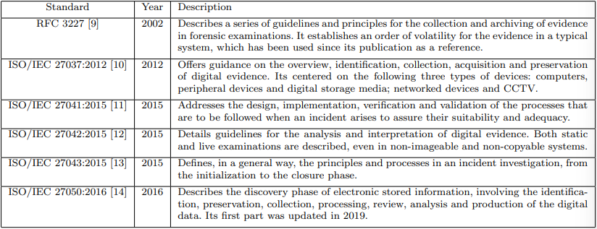
Table 1: Summary of Digital Forensic Standards
Related Work
- Many of the proposed methodologies so far are theoretical and few have practical validation
- Frameworks focus on cloud, network, and device layers, lack detailed produces, and ignore IoT heterogeneity from a general perspective because it’s not possible
- Tools such as Autopsy, Wireshark, Guymager, and Xplico are used for general digital forensics but lack the complexity to handle IoT devices
- References to specific proposals in Table 2
  - [16] E. Oriwoh, D. Jazani, G. Epiphaniou, P. Sant, in 9th IEEE International Conference on Collaborative Computing: Networking, Applications and Worksharing (2013), pp. 608–615
  - [20] A. Nieto, R. Rios, J. Lopez, in 2017 IEEE Trustcom/BigDataSE/ICESS (2017), pp. 626–633. DOI 10.1109/Trustcom/BigDataSE/ICESS.2017.293
  - [21] S. Perumal, N.M. Norwawi, V. Raman, in 2015 Fifth International Conference on Digital Information Processing and Communications (ICDIPC) (2015), pp. 19– 23. DOI 10.1109/ICDIPC.2015.7323000
  - [22] V.R. Kebande, I. Ray, in 2016 IEEE 4th International Conference on Future Internet of Things and Cloud (FiCloud) (2016), pp. 356–362. DOI 10.1109/ FiCloud.2016.57
  - [24] A. Goudbeek, K.K.R. Choo, N.A. Le-Khac, (2018), pp. 1446–1451. DOI 10.1109/TrustCom/ BigDataSE.2018.00201
  - [25] M.B. Al-Sadi, L. Chen, R.J. Haddad, in SoutheastCon 2018 (2018), pp. 1–5. DOI 10.1109/ SECON.2018.8479042
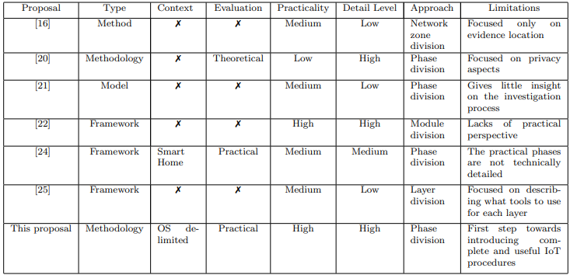
Table 2: Summary of Proposals from the Community and Comparison with this Research
Research Motivation
- The following features affect the examination process, which calls for a new approach to analysis:
  - Diversity of devices and systems: each device performs diverse tasks in different and specific contexts, none of them stand out in terms of market share and existing for general use
  - Connectivity: common IoT topologies of numerous devices that interact with each other so each device should be examined
  - Computational capacities: the data stored is both volatile and non-volatile memory with a very short lifetime
  - Interaction with the cloud: many systems store data remotely, which makes physical access impossible and require legal processes to obtain the cloud data
  - Physical access: devices are embedded into other objects and spread across different locations, meaning acquisition methods must be flexible and provide multiple collection methods depending on whether the investigator has access to the device
  - Battery life: devices may shut down during analysis, which can alter data by restarting the device
- Because IoT devices are so different, one universal methodology is unrealistic
- Methodologies should focus on specific contexts, similar devices, and similar operating systems, which allows for practical guidance and generalizable insights
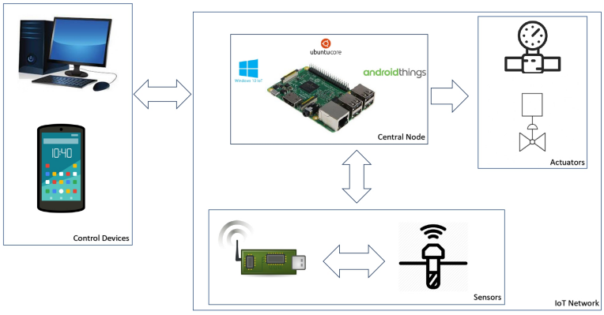
Proposed Methodology for Forensic Investigations in the IoT Environment
Figure 1: Topology the Methodology is Based on
- This methodology targets systems with central IoT node managing networks, sensors/actuators connected
- Operating systems considered are Windows 10 IoT core, Ubuntu core, and Android things because they have similar architectures, comparable storage systems, and are widely used in IoT deployments
- This aligns with traditional forensics and makes changes to add IoT-specific considerations, allow for flexible acquisition, and support live analysis
- Phases
  - Preparation: determines which devices in the scenario can contain relevant data; connectivity is key here because multiple devices will be looked at depending on the most plausible origin device
  - Acquisition: collect data from device storage, network logs, and cloud services to create forensic copies for analysis; more complex because most devices aren’t reachable physically so remote acquisition, network capture, and live data collection is utilized the most
  - Analysis: inspects the data of every chosen device and extract system logs, user activity, application data, and communication traces to determine what happened; more extensive than traditional forensics because of the different data formats, live analysis is the best option in most situations
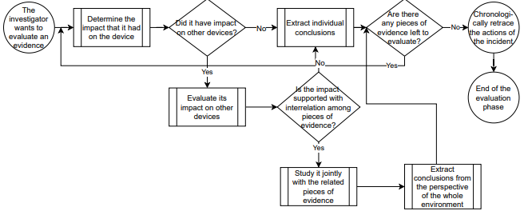
  - Evaluation (replaced Presentation phase): group all info collected and conclude how it fits into the environment by building an event timeline, identifying attacker actions, and validating evidence relationships (see Figure 2 for logic)
Figure 2: Flowchart of Evaluation Phase
  - Post-process: returning evidence, writing the report, and return system to its functioning state
Practical Evaluation of the Proposed Methodology
- The methodology was tested in 3 security incidents
  - DoS attack in Windows 10 IoT core
    - Attackers flooded the Raspberry Pi with requests
    - Event logs, network traces, and application logs
    - Central node was quickly found and timeline was easily reconstructed
  - Malware infection in Ubuntu core
    - Malware was installed, modified system behaviour, and established persistence
    - File system analysis, process inspection, and system logs were examined
    - The compromised node was found, the malicious files were identified, and the timeline linked the infection steps taken
  - Internal attack in Android Things
    - Legitimate access was abused to perform unauthorized actions
    - User activity logs, application logs, and system configuration records were examined
    - Evidence sources extended beyond device storage, focus was placed on user interactions, and insider actions were reconstructed
  - Found that this process identified attack paths, recovered evidence from IoT storage, and live analysis proved effective in IoT scenarios
Conclusions
- Research suggests that:
  - Volatile memory forensics in IoT must be investigated
  - IoT-specific tools must be developed
  - Parts of the investigation process and be automated
  - Methodologies should be expanded to other contexts
  - Should consider Digital Forensic as a Service
IoT Forensics Readiness – Influencing Factors
Introduction
- In 2020, the number of IoT connections surpassed the number of non-IoT connections for the first time
- By 2025, it is expected that there will be more than 30 billion, estimated 4 IoT devices per person
Background
- An IoT environment is divided into 3 zones: Cloud, Network, and Devices
  - The devices produce or collect data and send it over a network into the cloud, where data is aggregated, sorted, and processed
- IoTF (IoT forensics) is still a relatively new and unexplored area in research and practice
  - First defined by Oriwoh et al. with 3 zones: internal network, middle, and outside/external network
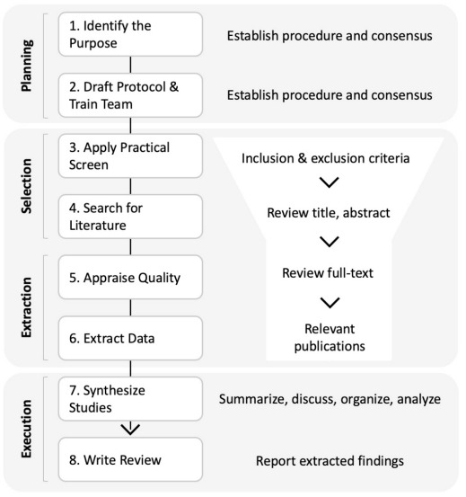
- IoT forensics readiness (IoT-FR): a process step to ensure stakeholders and organizations are well prepared for future IoT incidents, it should be fully supported operationally and infrastructurally by the organization
Figure 3: Methodology for Processing Literature with SLR
Literature Analysis
- Systematic literature review: conducted to obtain an overview of methods and concepts used and the current state of the art, follow established guidelines by Okoli (see Figure 3)
  - Identify purpose: can be determined by asking the following research questions (RQs)
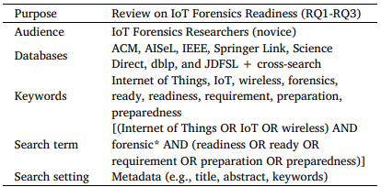
    - Which influencing factors can be extracted from literature? Major themes are technological resource and technique, management process, human factor, standardization approach, and legal aspect
Table 3: Planning of SLR
    - How relate the identified influencing factors to each other? Influencing factors are interdependent, differing from traditional FR because this introduces volatility, heterogeneity, and distributed data
    - What challenges arise in IoT-FR based on the identified influencing factors? (see Figures 5-9)
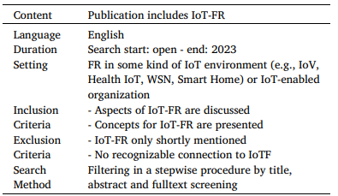
  - Draft protocol and train team: protocol serves as a plan to conduct the SLR, the review is based on articles published in one of the given databases, define keywords for the search (see Table 3)
Table 4: Selection of Relevant Literature
  - Apply practical screen: define and explain the criteria for selecting or excluding work (see Table 4)
  - Search for literature: after the results of step 3, they were reviewed and reduced as defined by the methodology
  - Appraise quality: review the full text of the papers to review their quality
  - Extract data: identify relevant works by utilizing the databases and conducting a cross-search
  - Synthesize studies: summarize the papers selected to ensure a comprehensive understanding
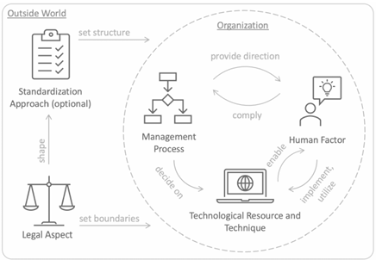
Correlations of Influencing Factors
Figure 4: Holistic Model of Influencing Factors and their Dependencies
- Business Process Modeling Notation model (process flow): deepens insights and shows how influencing factors can relate and function with each other, which leads to a management decision
  - Decide whether to implement IoT forensics
  - Allocate resources such as funding, strategy, staff, etc.
  - Establish a forensics readiness team to prepare IoT environments using specific tools and techniques
  - Adopt typical standards and protocols for forensics readiness
  - Integrate legal requirements as needed
  - Use internal and external incident data to refine readiness as things evolve
  - Report maturity level of IoT forensics readiness (IoT-FR) to management and make changes if the desired level isn’t met yet
Influencing Factors on IoT-FR
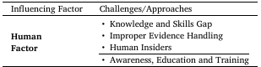
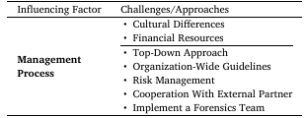
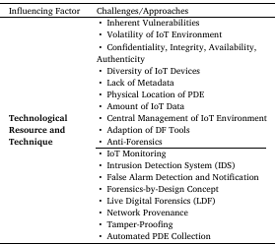
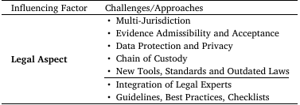
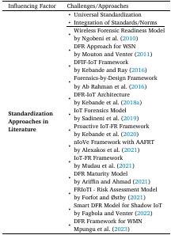
- Challenges and Approaches with IoT-FR
Figures 5-9: Challenges and Approaches connect to the Specified Influencing Factor
Threats to Validity
- Construct validity: there is a possibility that relevant work could be overlooked due to the selection process of relevant publications
- Internal validity: guidelines are strictly set by Okoli, the process of publication selection is applied by two researchers, and only online libraries are used during the search
- External validity: selected publications are based on factors influencing IoT-FR and the search term definition
- Conclusion validity: there could be a divergence between researchers, the relevance of extracted data for RQs is in question, and the consistent extraction of relevant information can influence how to define a data extraction strategy
Future Recommendations and Research Challenges
- Incentives: influences positive or negative actions to influence individuals or organizations in a certain way
- Maturity models and metrics: applied to measure the Digital FR (DFR) of IoT environments, model evaluates an organization’s maturity level, indicating its capacity and ability for ongoing improvement in a specific discipline
- Crowdsourcing and crowdsensing: soliciting information or input on a task through the involvement of many people via the internet
- Green computing: efforts to use information and communication technology environmentally and resource-friendly throughout its entire lifecycle, discussed in research for a while, in only a few paradigms work with forensic sciences
- Blockchain: a decentralized, distributed, and transparent nature that fostered research if blockchain into storage, processing, and examination of digital evidence, can enhance transparency and tamper-proof chain of custody
- Post-quantum cryptography: secure against both quantum and classical computers and can work with existing communication protocols and networks
Smartwatches in Crime Investigation and Digital Forensics
Introduction
- Smartwatches collect and track an individual’s day-to-day activities, making them invaluable sources of evidence in forensic investigations
  - Can verify a person’s location, reconstruct timelines, establish activity patterns, and assess physical state during specific timeframes
Background
- Wearable technology includes fitness trackers, smartwatches, smart clothing, smart eyewear, Whoop bands, and smart rings
  - Equipped with sensors and technology to collect and monitor various data including health metrics, location information, and environmental data
  - Some have Bluetooth, NFC for payments and microphones
- With devices becoming more significant in our lives, they have become crucial sources of evidence in modern investigations, which is why we need digital forensics
- 6 forensic investigation stages
  - Identification: the process of identifying digital evidence
  - Collection: obtaining digital evidence from the crime scene
  - Extraction: retrieve evidence from the infected device(s) (see Figure 10)
  - Analysis: decide whether to prove or deny the crime by interpreting and comparing evidence
  - Examination: look at the evidence and its characteristics
  - Report: compile results into a report
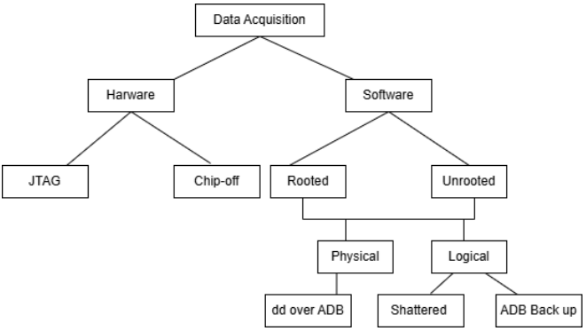
- These devise store vast amounts of data, which can be invaluable as evidence, but each OS stores it differently depending on the OS and the device itself
Figure 10: Data Acquisition Techniques
  - Common approach: extract data from the watch’s corresponding application (usually a mobile app)
- Real-world Fitbit case studies
  - Karen Navarra was murdered by her stepfather. He initially claimed he wasn’t at her home when she died but her Fitbit data confirms she was dead 5 minutes before he left (more on the story https://www.bbc.com/news/technology-45745366)
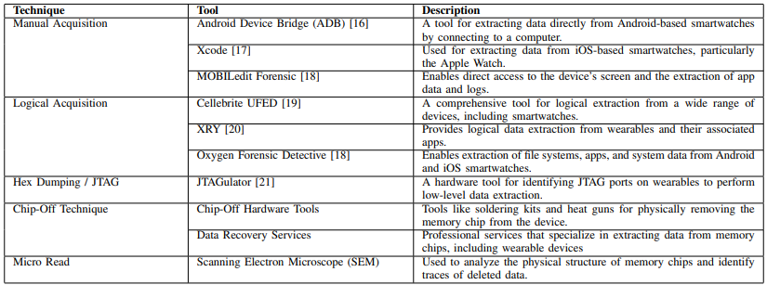
  - Mollie Tibbets disappeared while jogging. Her Fitbit showed her jogging path to show her last known location, which focused the search regions.
Figure 11: Tools and Techniques for Smartwatch Data Extraction
Methodology
- Things that can be found from Fitbit devices after data is extracted
  - User’s heart rate during a certain time period
  - Physical activities during the day
  - Calorie consumption and step count
  - Unusual inactivity or intense activity that might indicate an incident
  - User’s sleep data with the timeline of the event
  - Where the user was during a certain time period
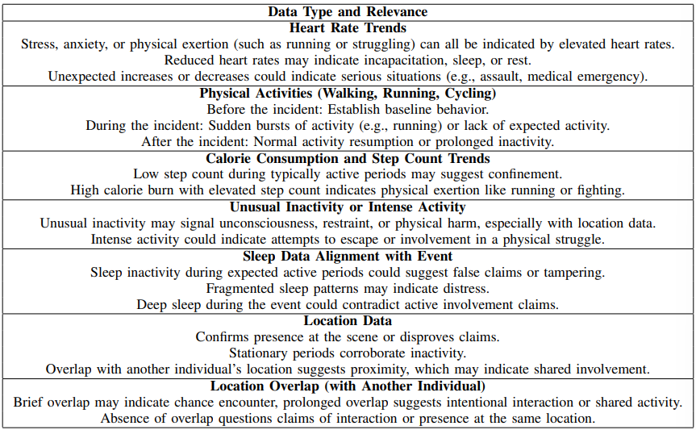
  - Was the user’s location coordinated with someone else’s at any point in time?
Figure 12: Data Type & Relevance for Incident Analysis
Experiments and Findings
- To analyze the Fitbit application on a mobile device, it must be connected to Magnet AXIOM (digital forensics tool)
- Allows access to the application’s data directory, which holds all data collected while the user wears the device
  - There are several databases, each containing records associated to various metrics tracked
  - Each database stores minute-by-minute data to provide insights on the user’s activities, queries can be used to extract and analyze required data
- Generative AI models can also use the data to find patterns between two users over a given timeframe; they evaluate location data using ML approaches to find possible overlaps in movement, shared places, or proximity at particular periods
- Tools like Oxygen Forensics, Belkasoft, Cellebrite, and Mobiledit can also be used for data extraction

